Mingjie Zhao HW10
a

There are 54 clusters
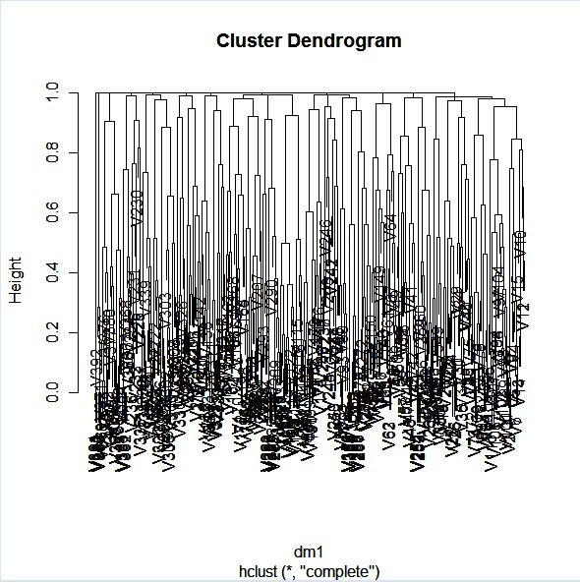

Codes:
amp = read.table("dna.txt",sep=" ")
amp = amp[,-394] # The 394th column is completely missing for everybody
tumor = read.delim("label.txt",sep="\t",header=F)
tumor = I(tumor[,2] == "Breast cancer")
tumor = ifelse(is.na(tumor),F,tumor)

# Code for demonstrating hierarchical clustering analyses in R

Y = as.matrix(amp)
dm1 = dist(t(Y),method="binary")
# Default is complete linkage
hc1 = hclust(dm1)
plot(hc1)
tmp1 = cutree(hc1,h=0.8)
tmp1

b
There are 36 clusters
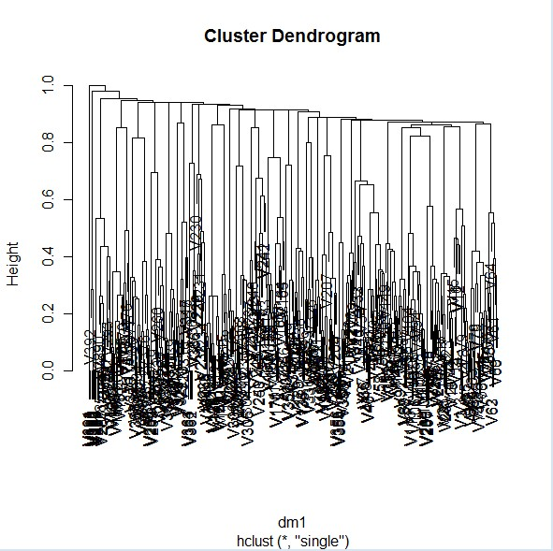

codes
hc2 = hclust(dm1,method="single")
plot(hc2)

# Cut based on dendrogram value
tmp2=cutree(hc2,h=0.8)
tmp2

c
After repeat, for method in (a), there are 6 clusters,
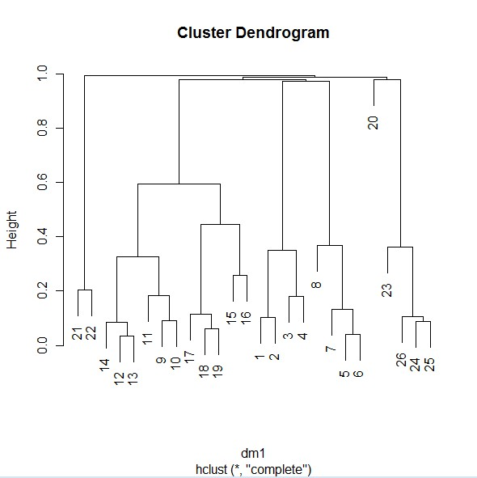
for method in (b), there are 6 clusters
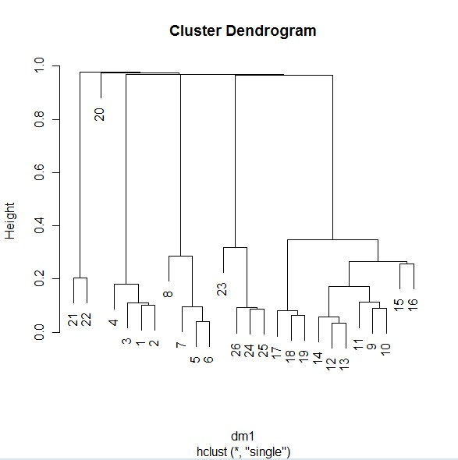

Codes
z=ncol(Y)
n=0
for(i in 1:z)
{if (sum(Y[,i])>199)
n=n+1
}
X=matrix(0, nrow=4590, ncol=n)
j=1
for(i in 1:z)
{if (sum(Y[,i])>199)
{X[,j]= Y[,i]
j=j+1}
}
dm1 = dist(t(X),method="binary")
# Default is complete linkage
hc1 = hclust(dm1)
plot(hc1)
tmp1 = cutree(hc1,h=0.8)
tmp1

hc2 = hclust(dm1,method="single")
plot(hc2)

# Cut based on dendrogram value
tmp2=cutree(hc2,h=0.8)
tmp2

d
Cannot associate the clustering results with tumor label, because results in a-e are from clustering the columns. But the tumor is for each row vector. If we cluster the rows we could associate the cluster results with the tumor label.

e
Fisher's Exact Test for Count Data

data: km2$cluster and tumor
p-value = 0.0001691
alternative hypothesis: two.sided
The null hypothesis is rejected, means when k=3, Cluster and tumor Type are not independent.

codes
# K-means with K = 3
km2 =kmeans(Y,3)
fisher.test(km2$cluster,tumor)

f
Cannot use chisq.test because chisq.test needs large sample size, which means every factor in the following table should be larger than 5, but there are 0 and 3 in the table, so it is not valid.

tumor
FALSE TRUE
1 52 0
2 4082 274
3 179 3
> codes
table(km2$cluster, tumor)

